PYTHON ASSIGNMENT
CLASS = MCA(AI/ML)
SUBJECT = PYTHON
NAME = KHUSHI PANWAR
ASSIGNMENT 1 = PROBALAM SOLVING and ADVANCED PROGRAMMING CONCEPTS
ROLL NO = 2501940062
GITHUB = https://github.com/panKhushi
COURSE TITLE: ETCCPP171
DEPARTMENT = SOET
SUBMITTED TO = MISS. NEHA KAUSHIK

ABOUT ATTENDENCE TRACKER
A simple Python-based Attendance Tracker System that records and manages student attendance. It allows users to input student names, check-in times, view summaries, and save attendance reports with date and time to a text file for easy tracking and record-keeping.

TASK ONE
# For getting current date and time
from datetime import datetime

# Welcome message
print("===========================================")
print(" Welcome to the Attendance Tracker System ")
print("===========================================")
print("This tool helps record and manage student attendance.")
print("You can add, view, and summarize attendance records easily!")
print()

TASK TWO
# Ask number of entries
num_entries = int(input("How many attendance entries do you want to record?"))

# Create dictionary to store attendance
attendance = {}

# Loop to collect data
for i in range(num_entries):
print(f'\nEntry{i+1}')
# Get student name and validate
while True:
name = input("Enter the Student Name:").strip()
if name == "":
print("Name cannot be empty.Please enter a valid name.")
elif name in attendance:
print("This student's name already exists.Please enter a different name. ")
else:
break #valid name entered

# Get check-in time and validate
while True:
time = input("Enter check-in time:").strip()
if time == "":
print("Check-in time cannot be empty.Please re-enter the time")
else:
break #valid time entered
attendance[name] = time

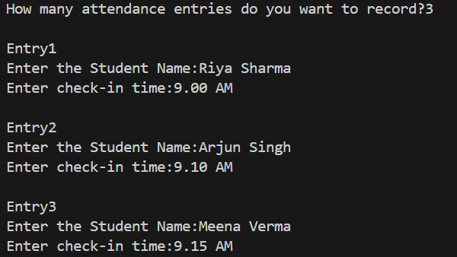

TASK THREE
# Get student name and validate
while True:
name = input("Enter the Student Name:").strip()
if name == "":
print("Name cannot be empty.Please enter a valid name.")
elif name in attendance:
print("This student's name already exists.Please enter a different name. ")
else:
break # valid name entered

# Get check-in time and validate
while True:
time = input("Enter check-in time:").strip()
if time == "":
print("Check-in time cannot be empty.Please re-enter the time")
else:
break # valid time entered

TASK FOUR
# Ask for total class strength
total_students = int(input("\nEnter total number of students in the class: "))

# Calculate attendance summary
total_present = len(attendance)
total_absent = total_students - total_present

print("\n\n\tATTENDANCE SUMMARY")
print("\t----------------------------")
print(f"{'Student Name':<20}\t{'Check-in Time'}")
print("\t------------------------------------------")

# Display each record using f-string formatting
for name, time in attendance.items():
print(f"\t{name:<20}\t{time}")

print("\t--------------------------------------")
print(f"\n\tTotal Students in Class: {total_students}")
print(f"\tTotal Present: {total_present}")
print(f"\tTotal Absent: {total_absent}")
print("\n\tThank you for using the Attendance Tracker!\n")

TASK FIVE
# Ask for total class strength
total_students = int(input("\nEnter total number of students in the class: "))

# Calculate attendance summary
total_present = len(attendance)
total_absent = total_students - total_present

TASK SIX
print(f"\n\tTotal Students in Class: {total_students}")
print(f"\tTotal Present: {total_present}")
print(f"\tTotal Absent: {total_absent}")

OUTPUT

